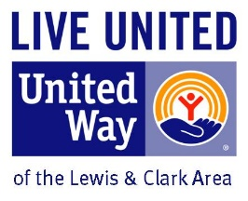

United Way of the Lewis and Clark Area
Childcare Assistance Application Summer 2020
For children ages 5-12

Primary Adult Name: _______________________________________________________ Date of Birth ______/_______/_________
Household Address: ______________________________________________City: __________________ State: _____ Zip:_________
E-mail: __________________________________________________________ Phone: _____________________________________
Employer or School: _ __________________________________________________________________________________________

Secondary Adult Name: _____________________________________________________Date of Birth _______/_______/_________
E-mail: __________________________________________________________ Phone: _____________________________________
Employer or School: ___________________________________________________________________________________________

Please list ALL persons living in household included on membership. Adults: ____________ Children (under age 18) ______________
________________________________________ D.O.B. __________________ Childcare Center/Employer _____________________
________________________________________ D.O.B. __________________ Childcare Center/Employer _____________________
________________________________________ D.O.B. __________________ Childcare Center/Employer _____________________
________________________________________ D.O.B. __________________ Childcare Center/Employer _____________________
________________________________________ D.O.B. __________________ Childcare Center/Employer _____________________
________________________________________ D.O.B. __________________ Childcare Center/Employer _____________________

Assistance is based on income and need. To process your application, the following documentation is required for all adults living in the household. Applications must be complete:

- Copy of last year’s Tax Return for all adults living in the household
- Statement of current income, need, how COVID-19 has affected your income and need for assistance with childcare costs.

Awards are made on a sliding fee scale based on income. Awards are made on a first come, first served basis.

Payments will be made directly to the childcare facility the child attends.

Please return form to United Way of the Lewis and Clark Area 75 East Lyndale Helena, MT 59601.

